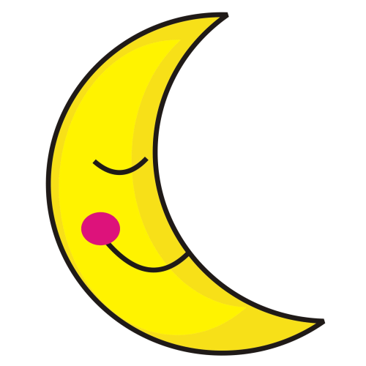  Midnight  to  Start of school day  My school day begins at  _______a.m. | Follow HIDOE Wellness Nutrition Guidelines
 | Food Guidelines
 | - Be whole grain-rich  - First ingredient must be: whole grain, fruit, vegetable, dairy product, or protein food  - Be a combination food that contains of ≥ ¼ cup of fruit and/or vegetable | Calories |  | Snacks: ≤ 200 calories
 |  |  |  | Entrees: ≤ 350 calories
 |  | Sodium |  | Snacks: ≤ 200 mg
 |  |  |  | Entrees: ≤ 480 mg
 |  | Fat |  | Total Fat: ≤ 35% of total calories
 |  |  |  | Saturated Fat: ≤ 10% of calories
 |  |  |  | Trans Fat: Zero grams
 |  | Sugar |  | Snacks: ≤ 35% of total weight of item
 | Beverage Guidelines
 | Prohibited | Allowed
 | - Soda, coffee, flavored tea, and sports drinks (even without sugar)  - Caffeine, artificial colors, and artificial flavors  - Drinks with more than 8 oz. servings other than plain water | 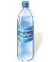  Water |  | Plain, with or without carbonation
 |  |  |  | No portion size limit
 |  | 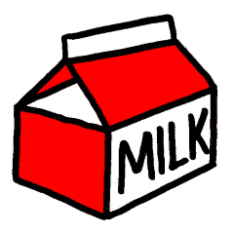  Milk |  | Unflavored 1% or fat free; flavored fat free; milk alternatives as permitted by NSLP
 |  |  |  | Less than or equal 22 grams of sugar per 8 oz. serving
 |  | 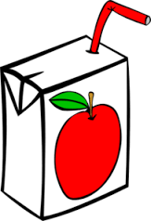  100%  F/V  Juice |  | Non-diluted, no added sweeteners, without carbonation
 |  |  |  | Diluted, no added sweeteners, with or without carbonation
Start of school day  to  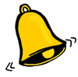  End of school day when the bell rings  My school day ends at  _______p.m. | Follow HIDOE Wellness  Nutrition Guidelines |  | Follow BOE Policy 103-7
 | Food and beverages provided (not sold) on campus meets HIDOE Wellness Nutrition Guidelines. Examples of where this applies are for:  - Class celebrations  Food (including beverage) is not used as a reward or punishment for students.  - Any food provided other than culinary arts classes |  | No food and beverage sold (outside of the school meals program) except for plain water, such as:  - School stores  Note: Food (including beverage) is not used as a reward or punishment for students.  - Vending machines (except for plain water)  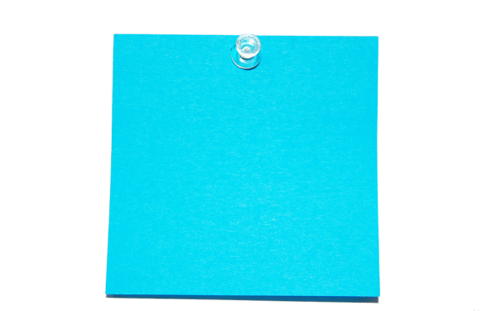  REMINDER: If participating in USDA’s afterschool snack program, end of school day is 30 minutes after snacks are served.
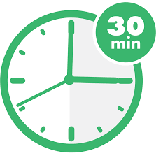  End of school day to 30 minutes after the bell rings | Follow HIDOE Wellness Nutrition Guidelines  Refer to food and beverage guidelines chart from above.

Glossary and Additional Resources

Combination Food: A product that contains two or more foods representing two or more of the food groups: fruit, vegetable, dairy, protein or grains.
Examples of combination foods: smoothie, blueberry muffin (containing 1/4 c blueberries)

Entrée: An item that is
- a combination food of meat or meat alternate and whole grain-rich item;
- a combination food of fruit or vegetable and meat or meat alternate; or
- a meat or meat alternate alone, with the exception of yogurt, low fat or reduced fat cheese, nuts, seeds and nut or seed butters and meat snacks (such as dried beef jerky)

F/V: Fruit/Vegetable

Fundraiser: An event that includes any activity during which currency/token/tickets, etc. are exchanged for the sale/purchase of a product in support of the school or school related activities. For example, giving away food but suggesting a donation would be considered a fundraiser since funds will be raised as a result. Purchasing tickets or tokens to be exchanged for food items would also be considered to be a sale of food and/or a fundraiser and would be subject to the Smart Snack standards.

NSLP and NSBP: The National School Lunch Program and National School Breakfast Program are federally assisted meal programs operating in public and nonprofit private schools and residential child care institutions. The programs provide nutritionally balanced, low-cost or free breakfast, lunches, and afterschool snacks to children each school day.

School Campus: All areas of the property under the jurisdiction of the school that are accessible to students during the school day.

Whole Grain-Rich: Contains 100 percent whole grain or a blend of whole-grain meal and/or flour and enriched meal and/or flour of which at least 50 percent is whole grain. The remaining 50 percent or less of grains, if any, must be enriched.

Calculators:
- Smart Snack calculator: https://www.healthiergeneration.org/take_action/schools/snacks_and_beverages/smart_snacks/alliance_product_calculator/
Note: Do not use to calculate nutrition requirements for beverages.

- Scratch-made items calculator:
https://www.supertracker.usda.gov/myrecipe.aspx or
http://nutritiondata.self.com

Resource:
- Products that meet Smart Snacks:
https://foodplanner.healthiergeneration.org/products

